Project Report Template

**CRM APPLICATION THAT HELPS TO BOOK A VISA SLOT**

1. **INTRODUCTION**

* *Overview*

CRM application that helps to book a visa slot can have a variety of functions and futures to make the process of book a visa slot as seamless and efficient as possible. Welcome to our CRM application! We are here to make your visa application process as easy as possible with our platform you can quickly and easily book a visa slot that fits your schedule.

* *Purpose*

Customers want a simple and easy-to-use platform to book a visa slot.

* They want to be able to access the platform from any device at any time.
* Customers want to know what documents they need to prepare for the visa application process.
* Whether you need to apply for a tourist visa, student visa, or work visa, our platform makes it easy to find and book a visa slot that meets your needs.

1. **Problem Definition & Design Thinking**

* *Empathy Map*
* *Ideation & Brainstorming Map*
* *Courses videos completed screen shot.*

1. **RESULT**

* *Data Model:*

|  |  |  |  |  |
| --- | --- | --- | --- | --- |
| **Object Name** | | **Fields in the object** | | |
|  | |  | |  |
| **CRM applications** | | Field label | | Data type |
|  | | Record name | | CRM application name |
|  | | CRM application | | Text |
| **Customer** | | Visa | | Text |
|  |  | |  | | |
| **Apple** | Apple | | Text | | |
| **Books** | Createdbyid | | Text | | |

**Activity & Screenshot**

To create an object:

Creation of Objects for Vehicle Management to create Vehicles object.

* Go to setup, click object manager
* Click save.

Similarly create Driver Object

Lets create custom field

To create field in vehicle object

* Go to setup, click object manager.
* Select vehicle object.

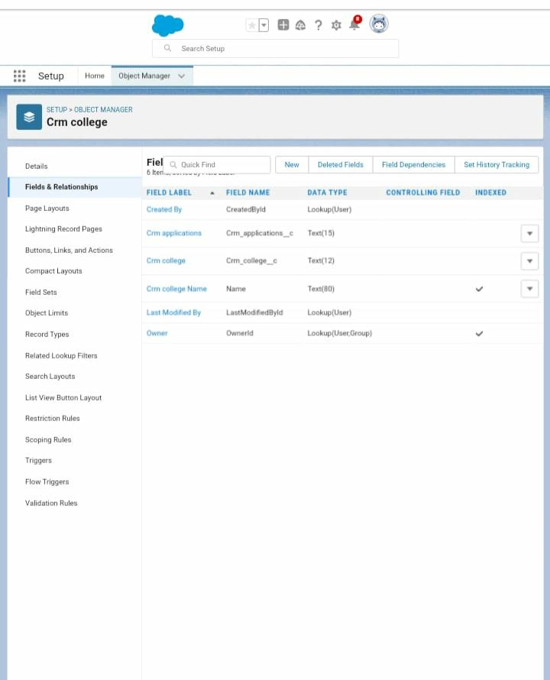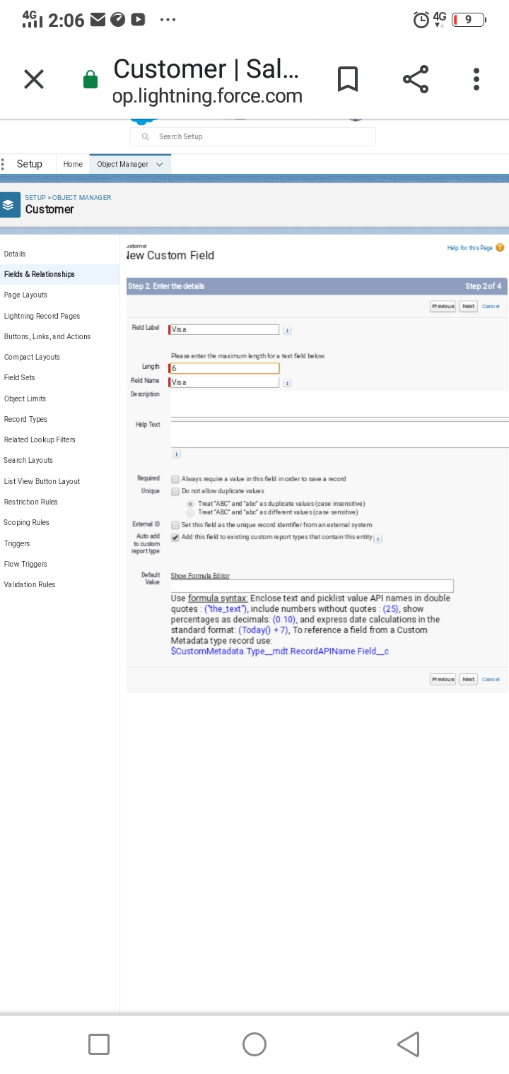

❖ Click new Click create and select custom object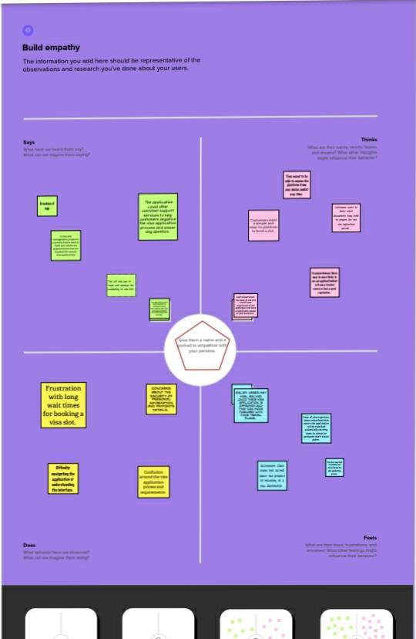

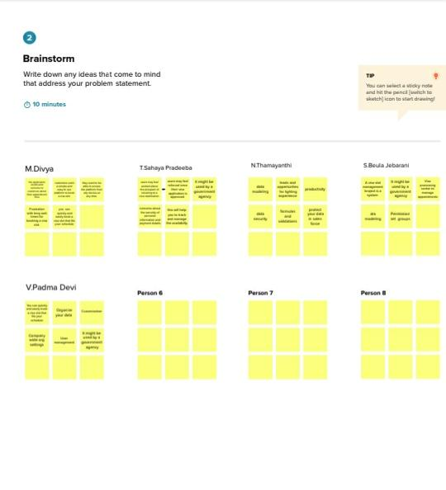

1. *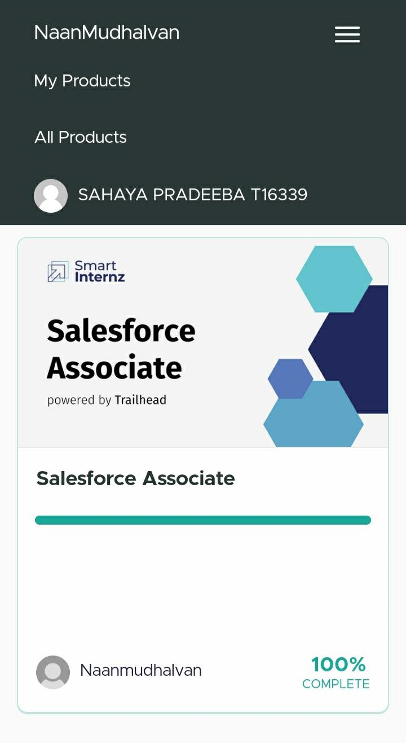***Trailhead Profile Public URL**

**Team Lead -** [**https://trailblazer.me/id/thamn3**](https://trailblazer.me/id/thamn3)

**Team Member 1 -** [**https://trailblazer.me/id/sahat2**](https://trailblazer.me/id/sahat2)

**Team Member 2 -** [**https://trailblazer.me/id/bbeulajebarani**](https://trailblazer.me/id/bbeulajebarani)

**Team Member 3 -** <https://trailblazer.me/id/padma15>

**Team Member 4 -** <https://trailblazer.me/id/dmariappan2>

**5. ADVANTAGES & DISADVANTAGES**

* *Excitement:* Users may feel excited about the prospect of travelling to a new destination, meeting new people, and experiencing different cultures. This excitement can motivate then to complete the visa application process quickly and efficiently.
* *Relief:* Users may feel relieved once their visa application is approved and they can move forward with their travel plans. This sense of relief can lead to positive feelings towards the application and the visa processing agency.
* *Fear of visa rejection:* Users may fear that their visa application will be rejected, potentially causing them to cancel or post pone their travel plans .
* *Frustration with the application process:* Users may become frustrated with the visa application process if it is lengthy, complicated or require a lot of documentation.
* *Users experience:* The ease of use and overall user experience of the application can have a significant impact on user behaviour. If the application is difficult to use or does not provide a seamless experiences users may be less likely to use it

**6. APPLICATIONS**

*Some possible behaviour and pain points that users may experience when using such an application include:*

1. Frustration with long wait times for booking a visa slot.
2. Confusion around the visa application process and requirements.
3. Difficulty navigating the application or understanding the interface.
4. Concerns about the security of personal information and payment details.

*Real-time visa slot availability:*

The application could have a real-time display of available visa slots and their corresponding dates and times, allowing users to easily choose the most suitable time for them.

**7. CONCLUSION**

As a CRM application designed to help people book a visa slot, their wants, needs, hopes and dreams. So, the application time and any necessary documents they need to bring. The application could offer customers support services to help customers negative the visa application process and answer any questions.

**8. FUTURE SCOPE**

* We understand that the process of booking a visa slot can be complicated and time-consuming. That's why we have designed our CRM application to streamline the process and guide you every step of the way.
* Users of a CRM application that helps to book a visa slot may experience a range of fears, frustrations, and anxieties during the visa application process.

________________________________________________________________________________